Armond Drew Byford
09/27/2026
Module 9 – Milestone #3

Group: Group A

Team Mambers:
Armond Byford
Arrington Capehart
Brittany Smith

Case Study: Outland Adventures

Revised Entity Relationship Diagram

The revised ERD below represents the finalized Outland Adventures database structure used for the Milestone #3 reports.

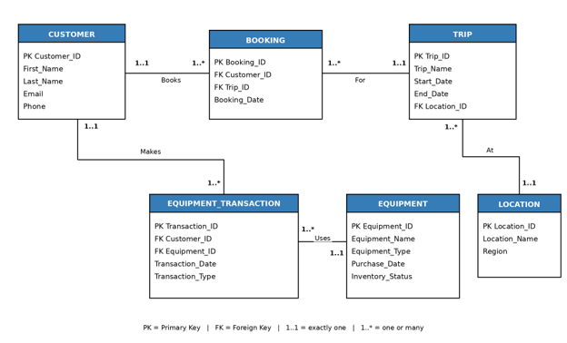Figure 1. Revised Entity Relationship Diagram for Outland Adventures

Report 1 – Equipment Purchases vs. Rentals

Report Description

This report compares the number of equipment purchases and rentals made by customers. The report helps Outland Adventures evaluate customer equipment activity and determine whether equipment sales continue to provide value to the business.

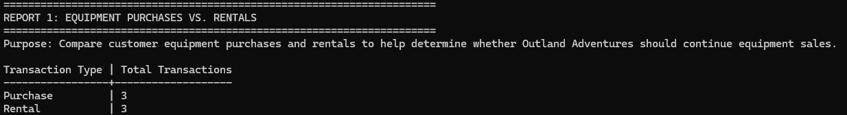Figure 2. Equipment Purchase and Rental Activity Report

Result
The results show 3 purchases and 3 rentals in the current sample data.

Report 2 – Booking Trends by Region

Report Description

This report displays monthly bookings for Africa, Asia, and Southern Europe. It allows Outland Adventures to identify changes in booking activity over time and determine whether any region is experiencing a downward trend.

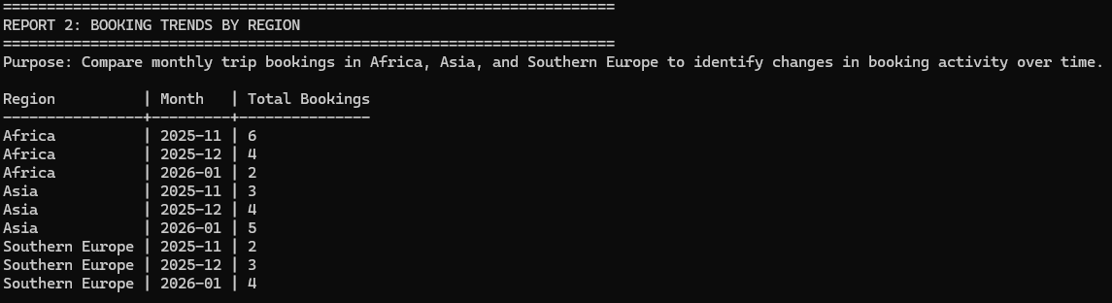Figure 3. Monthly Booking Trends by Region

Result
In the sample data, Africa decreases from 6 bookings in November to 4 in December and 2 in January, while Asia and Southern Europe increase over the same period.

Report 3 – Equipment More Than Five Years Old

This report identifies equipment that was purchased more than five years ago. The information can help Outland Adventures identify aging inventory that may require inspection, replacement, or retirement
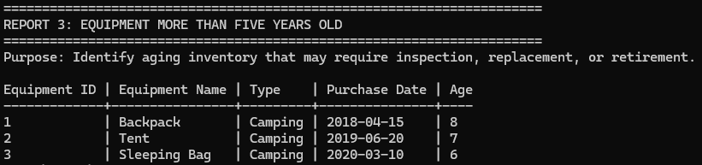Figure 4. Equipment More Than Five Years Old

Result
The report identifies the Backpack, Tent, and Sleeping Bag as equipment more than five years old.

Summary
The three reports address the primary business questions identified in the Outland Adventures case study. The reports provide information about equipment sales activity, regional booking trends, and aging equipment inventory.

